Multiple choice section

Question 1 [7.2]

Paul has downloaded 12 songs from a 35-track double album. If s represents the number of songs still to download, an equation that can be formed is:

A s – 12 = 35 B s + 12 = 35 C 12s = 35 D 12s = 35

Question 2 [7.3]

The expression missing from the box below is:

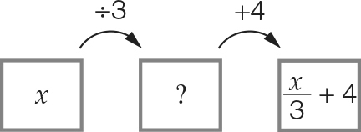

A x + 3 B 3x C  D 4x

Question 3 [7.2]

The perimeter of a rectangular frame is 74 cm. If the length is 22 cm and width x cm, then:

A 2x + 22 = 74 B 2x + 44 = 74 C x + 22 = 74 D 2x + 74 = 44

Question 4 [7.2]

Two times a number plus seven is equal to twenty one is the same as:

A 2n + 7 = 21 B 2 + n + 7 = 21 C n + 7 = 21 D 2n – 7 = 21

Question 5 [7.4]

The equation  = 12 has the solution:

A x = 7 B x = 11 C x = 12 D x = 36

Question 6 [7.2]

A number subtracted from forty-eight is equal to nine multiplied by four. The number is:

A 60 B 12 C 24 D 27

Question 7 [7.3]

Using backtracking, the first step to solve  + 11 = 15 is to:

A multiply both sides by 4 B add 11 to both sides

C divide both sides by 4 D subtract 11 from both sides

Question 8 [7.4]

The equation 7x – 3 = 18 has the solution:

A x = 1 B x = 2 C x = 3 D x = 4

Question 9 [7.4]

Solve the equation .

A x = 7 B x = 8 C x = 9 D x = 10

Question 10 [7.2]

Which equation describes the time (t) taken plus 15 minutes equals 45 minutes?

A 15t = 45 B t + 15 = 45 C 15 – t = 55 D 15 – t = 55

Question 11 [7.2]

Melissa has $45.50. She buys a new ball and has $14.45 left. If x represents the cost of the ball in cents, the equation representing this situation is:

A  B  C  D 

Multiple-choice total marks: ____ / 11

Short answer section

Question 12 2 marks [7.3]

operation unknown inverse solution equivalent

(a) When backtracking, you undo an operation by using the _______________ operation.

(b) To solve an equation is to find the value of the _______________.

Question 13 2 marks [7.3]

Describe the process of backtracking. Use an example to help you explain.

Question 14 3 marks [7.1]

State true (T) or false (F) for each number sentence.

(a)  (b) 28 – 6 × 2 = 4 + 18 – 6 (c) 5 × 3 = 

Question 15 1 mark [7.1]

Teo is 23 cm taller than Juan. If Juan is 119 cm tall, write a number sentence to find Teo’s height.

Question 16 3 marks [7.2]

Write each of the following equations in words.

(a) y + 2 = 8

(b) 

(c) 

Question 17 2 marks [7.2]

For the following equations, check whether the value given in the brackets is the correct solution.

(a) b + 7 = 10 (b = 3) Yes or No

(b)  (x = 12) Yes or No

Question 18 2 marks [7.3]

Write, in order, the missing operations needed to complete each of the following flowcharts.

(a)

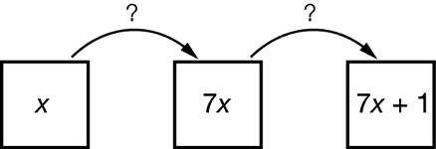

_______________, _______________

(b)

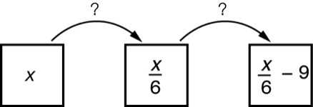

_______________, _______________

Question 19 2 marks [7.3]

The following flowchart represents an equation.

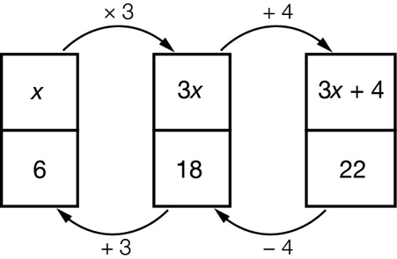

(a) What is the equation to be solved?

(b) What is the solution to the equation?

Question 20 2 marks [7.3]

Draw a flowchart and use backtracking to solve the equation 7x + 4 = 25.

Question 21 2 marks [7.3]

Draw a flowchart and use backtracking to solve the equation ****+ 3 = 7.

Question 22 4 marks [7.4]

Solve each of the following equations.

(a)  (b) 

Question 23 2 marks [7.4]

A number is doubled then eight added to the result to give an answer of twenty-six. Write an equation and then solve. Use n to represent the unknown number.

Question 24 6 marks [7.4]

Form an equivalent equation to each of the following by performing the operation given in brackets to both sides of the equation. Check that each pair of equivalent equations has the same solution.

(a) x + 9 = 12 (+ 4)

(b) x – 11 = 14 (+ 2)

(c) x – 7 = 3 (– 8)

Question 25 6 marks [7.4]

Solve each of the following equations using the balance method.

(a) 4x + 8 = 40 (b)  (c) 7(x – 3) = 28

Question 26 3 marks [7.5]

Bob drives a bus from the depot to a school each morning and back again in the afternoon. Twice a week, he drives another 125 km each for excursions. If he drives a total of 648 km every week, how far is the depot from the school?

Question 27 2 marks [7.5]

Aaron bought a drink and a sandwich for $9.60. The drink cost $2.70. If c represents the cost of the sandwich, form an equation and solve it to find the value of c.

Question 28 3 marks [7.5]

Benny and Michael have $85 between them. If Benny has four times as much as Michael, how much do they each have?

Question 29 4 marks [7.5]

The perimeter of a rectangle is 72 cm. If its length is three times its width:

(a) find the dimensions of the rectangle.

(b) What is the area of the rectangle?

Question 30 3 marks [7.5]

Andrea has $410 to spend on three shirts. After buying them, she had $56 left over. Each shirt cost the same amount.

(a) Write an equation that shows this situation.

(b) How much did each shirt cost?

Short answer total:_________/54

Extended answer section

Question 31 3 marks [7.5]

Mr Ross has invented a domino algebra game. He places the following dominoes on the board and asks the class to arrange them in the shape below. Which three dominoes can be used to form a square so that the puzzle is complete? Circle them. (In dominoes you can join two ends of the same value.)

|  |  |  |  |  |  |  |  |
| --- | --- | --- | --- | --- | --- | --- | --- |
| Domino 1 | |  | Domino 2 | |  | Domino 3 | |
| 4a + 6 = 22 | a – 3 = 4 |  | a + 6 = 10 | a – 13 = 7 |  |  | 3a + 4 = 37 |
| Domino 4 | |  | Domino 5 | |  | Domino 6 | |
| 2a + 1 = 15 |  |  |  | a + 8 = 20 |  | 4(a + 1) = 32 | a + 15 = 17 |

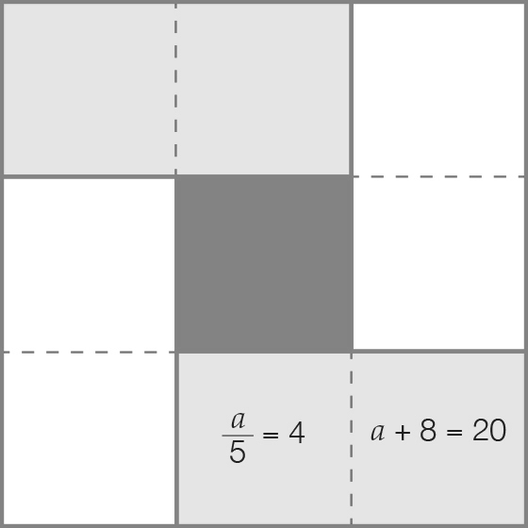

Question 32 5 marks [7.5]

A cookie factory has three machines. In a week:

* machine A makes four times as many cookies as machine B
* machine C makes 400 more cookies than machine A.

At the end of the week the three machines make a total of 20 200 cookies.  
How many cookies does each machine make in a week?

Question 33 6 marks [7.5]

In number pyramids, the square on top of the middle of two others contains their sum.

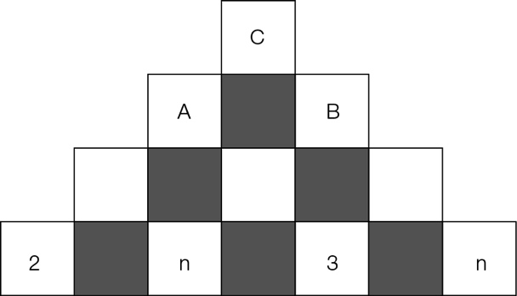

(a) Use the letter n to write expressions for the sums at positions A, B and C in the pyramid. (Write your answers in simplest form.)  
  
A: _______________________________________________________________________  
  
  
B: _______________________________________________________________________  
  
  
C: _______________________________________________________________________

(b) You are told that the top number is 15. Write an equation using n.

(c) Solve the equation from (b) for n. Check your answer in the pyramid.

Extended answer total:_________/14

TOTAL test marks: _______ / 79